Year 5/6 Summer Newsletter

With the Olympics this year it is the perfect time to complete a topic on Ancient Greece. We will be exploring Ancient Greek life ranging from their beliefs to the Olympics themselves.
In Literacy the Year 5/6 children will be looking at a range of literature from completing diary entries to producing recounts from the Battle of Marathon.
In our numeracy work we revising previous topics for the Year 6. We will also have a cross curricular link looking at ratio and scale as we explore Greek buildings.

The Science focus will be levers and pulleys. We will explore this as we try to replicate Greek temples as our DT project.

Our RE focus this term will be where/how and why people worship..

Important Events for the next term
• Year 5/6 Mountain Biking.
• Year 5/6 Trip to the Grand Opera House to see Horrible Histories Groovy Greeks.
• KS2 Countryside Day.
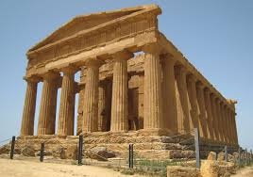
• SATS
• Summer Production.
• Y6 Visit to Fulford Secondary School
• Year 6 Leavers Assembly
• Sports Day

